New messaging guide helps frame
health benefits of civil legal aid
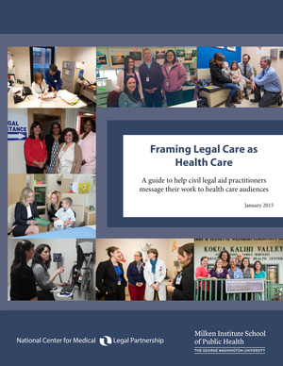
Framing Legal Care as Health Care
CLICK HERE TO DOWNLOAD THE GUIDE
The civil legal aid community is in a position to help improve the circumstances in which people live, work and play — the social determinants that can negatively impact health. But for health care leadership and policymakers to see civil legal aid as a valuable tool for improving health and invest in it, civil legal aid’s role in improving health and health care must be clear. This means re-framing civil legal needs as social determinants of health and describing the benefits of civil legal aid in health and health care terms.
This new guide from the National Center for Medical-Legal Partnership is intended to help civil legal aid practitioners message their work to health care audiences in order to build stronger cross sector medical-legal partnerships and to encourage investment in that work. The messaging guide helps:
- Translate common civil legal problems and interventions into health care talking points;
- Frame stories with effective messengers; and
- Cultivate stories and data to support four messages that every medical-legal partnership should be able to tell about civil legal aid’s impact on health and health care.
CLICK HERE TO DOWNLOAD THE GUIDE
BLOG

