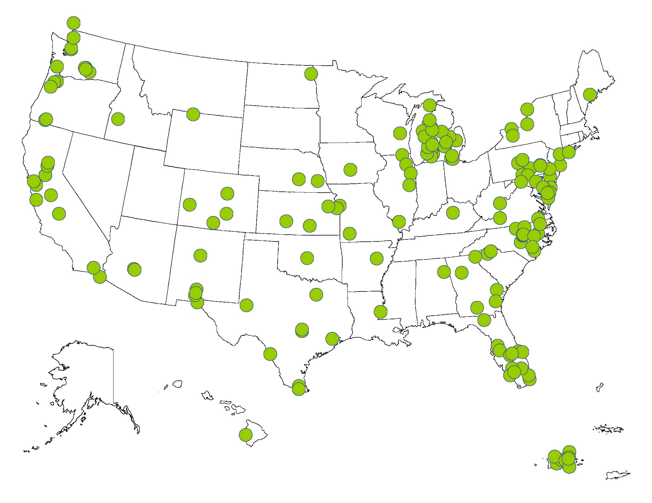
MCN 2013 Preliminary Pesticide Comic Book Distribution Campaign Report
Figure 2

Overview
Migrant Clinicians Network’s environmental and occupational health initiative engages stakeholders to improve the recognition, management and prevention of pesticide poisonings. MCN places priority on developing and disseminating culturally and linguistically appropriate educational materials to aid in minimizing pesticide exposures among migrant and seasonal farmworkers and their families.

With support from the EPA’s Office of Pesticide Programs, MCN is partnering with the National Association of State Departments of Agriculture (NASDA) to print and distribute 60,000 copies of each of the following pesticide comic books in 2013:
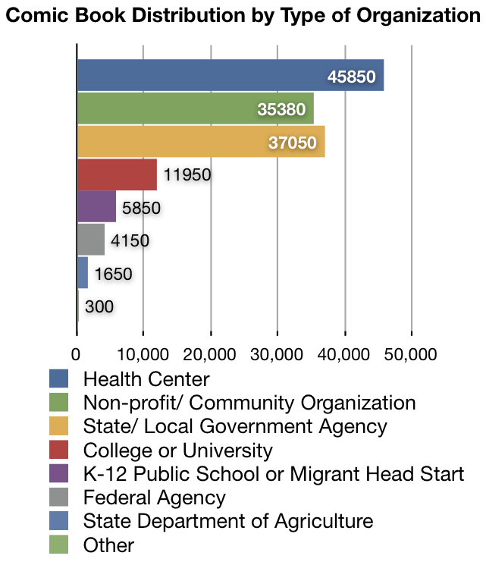
- Aunque cerca . . . Sano targets migrant and seasonal farmworker families, educating parents about children’s risks to pesticide exposure.
- Lo que bien empieza . . . Bien acaba addresses pesticide exposure in women of reproductive age.
- Poco veneno . . . ¿No mata? offers an educational story pesticide exposure risks, suggesting ways to minimize exposure in the home.
As shown in the Figure 1, MCN has distributed over 45,000 copies of each comic book. MCN has achieved the following:

- Distributed 142,180 pesticide comic books
- Reached 161 constituent organizations throughout the US and Puerto Rico
Figure 1
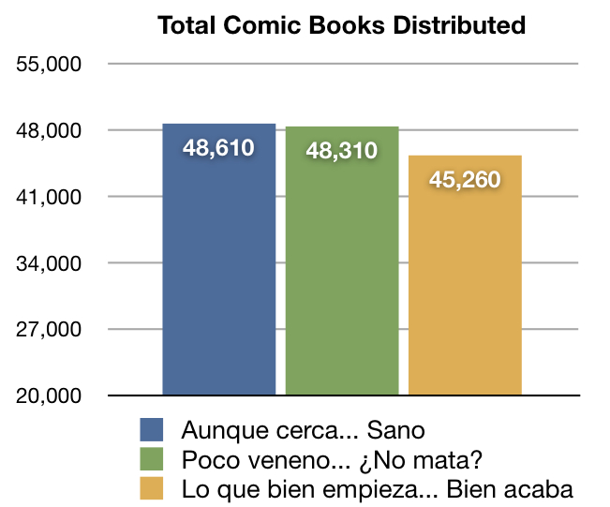
2013 Comic Book Distribution
The map in Figure 2 shows the geographic distribution of comic book recipients. MCN distributed comics to organizations in 36 states and Puerto Rico.

MCN collected basic data as part of the ordering process from all organizations who received comic books. The chart below shows the type of organizations and agencies that ordered MCN’s pesticide comic along with the number of comics these organizations ordered.
Figure 3

Health centers ordered about 32% of the pesticide comic books, both state/ local government agencies and non-profit organizations ordered about 25% of the comics distributed, and college or university programs accounted for about 8% of comics ordered.

Continued Distribution Plan
During the final quarter of the year MCN will continue to promote the availability of pesticide comic books on the MCN website, in a monthly e-newsletter to constituents and through other online promotion efforts. In addition, MCN plans to target health centers and community-based organizations in states who have significant populations of migrant and immigrant farmworkers in the fall and winter months – namely in citrus-growing regions of the US.

MCN will also target Ventanillas de Salud throughout the US. The Ventanillas are a program of the Mexican consulate and serve the immigrant and migrant community. MCN previously partnered with Ventanillas de Salud throughout Texas to disseminate health information to the immigrant and migrant community.

Furthermore, MCN plans to provide two health centers with comic books to support their outreach and patient education efforts as part of its Workers and Health Environmental and Occupational Health partnership program.

2013 Comic Book Evaluation
The pesticide comic books will be formally evaluated via an anonymous online evaluation to be emailed to recipient organizations on October 1, 2013. This evaluation will ask these organizations to provide feedback on the utility and relevance of the educational materials for the migrant and immigrant farmworker community. MCN also plans to ask recipients to suggest additional pesticide resources that could help to educate and improve the health of farmworkers in the community.

Constituent Feedback
Unsolicited email feedback demonstrates that MCN’s pesticide comics are an effective, culturally appropriate tool for disseminating health information to farmworker populations. Below are comments received from constituents during the 2013 campaign:

- Thank you for the educational materials about pesticides. Here in Puerto Rico, large quantities of pesticides and herbicides are used without precaution. There is only one person employed by the State Department of Agriculture for the entire island that distributes materials about the safety and use of pesticides.

- President of a nonprofit

- We are looking forward to receiving the comic books. We have given health education classes on Pesticide Safety for our farm workers over the years, and appreciate the addition of these materials.

- Clinical Nurse Coordinator at a West Virginia health center.

- I work in a FQHC clinic. These are PERFECT for our patients!

- Family Nurse Practitioner from the Midwest

